From: https://rescue.substack.com/p/a-myth-is-born-how-cdc-fda-and-media

A Myth is Born: How CDC, FDA, and Media Wove a Web of Ivermectin Lies That Outlives The Truth

New Mexico officials admit they were wrong: Two people died from covid. NOT from ivermectin. Yet the CDC generated the nation's highest health alert and a thousand fake headlines on false cases.

Linda Bonvie

and

Mary Beth Pfeiffer

13 hr ago [Date: Dec 23, 2021]

An ornament with a photo of the Texas cattleman, whose death was falsely attributed to ivermectin and used as part of a deliberate effort to make that perfectly safe drug appear to be highly dangerous, is lovingly hung on the family Christmas tree by his daughter.

When a Texas cattleman, seventy-nine, died last September in New Mexico after contracting covid, his family never anticipated the worldwide headlines that would ensue. In a ballyhooed press conference, New Mexico Human Services Secretary Dr. David Scrase, the state’s top health chief, announced New Mexico’s first ivermectin “overdose,” soon adding a second fatality allegedly from “ivermectin toxicity.”
Now, Scrase has acknowledged that his repeated, what he called “offhand,” assertions were groundless. Two deaths were not caused by ivermectin, a long-used generic drug that was emerging as a covid treatment. Instead, he said that the pair died because they “actually just delayed their care with covid.”
That is a big difference.
Scrase backpedaled on December 1 in a little-noticed online press briefing and only after we pressed his agency to provide evidence for its claims of so-called “ivermectin deaths.” Officials had repeatedly said they were awaiting a toxicology report on the cattleman’s death. Yet we learned that the report was never even ordered or done, and, moreover, the man’s death was ruled by the state’s coroner as being from “natural” causes.
Not a single media outlet reported Scrase’s admission, even as dozens, including the The Hill and The New York Times, had eagerly covered his original assertions about ivermectin, an anti-parasitic drug awarded the Nobel Prize in Medicine in 2015. “I don’t want more people to die,” read one early headline, quoting Scrase. “It’s the wrong medicine for something really serious,” Scrase said in the Times article.
Doctors, scientists, and toxicologists worldwide were puzzled by the assertions, because ivermectin is an extraordinarily safe, FDA-approved drug. A fixture on the WHO’s list of 100 essential medicines all hospital systems are recommended to carry, nearly four billion doses have been given in four decades.
New Mexico became a key player in a broad pattern of governmental deception late last summer to portray ivermectin as dangerous, in tandem with three related developments.
- Research strongly supported the drug’s efficacy against covid;
- prescriptions were soaring; and
- public health officials were single-mindedly focused not on treatment but on vaccination.
We previously reported that the U.S. Food and Drug Administration’s tweeted warning last August against using ivermectin meant for livestock was prompted by incorrect—and unverified—information from Mississippi. Health officials there had posted an alert suggesting the state’s poison control center was deluged with hundreds of calls over ingestion of livestock ivermectin; in reality, we found, four reports were received.
But, fueled by bits of contorted evidence like this, the anti-ivermectin train was unstoppable. We have now learned that, in the rush to bury a drug described as “astonishingly safe” and long used globally to quell animal and human parasites, FDA was not alone.
Emails we obtained from the U.S. Centers for Disease Control show that an influential August 26 national health alert on ivermectin was spurred, like the FDA tweet, by a sliver of evidence: just three cases of alleged ivermectin side effects, two involving animal formulations. No patient died; one appeared to have been hospitalized, and one declined any medical help.
Nonetheless, those three reports, obtained by Atlanta-based CDC from the Georgia poison control center, sealed the decision to issue the nation’s highest-level health warning, according to the emails.

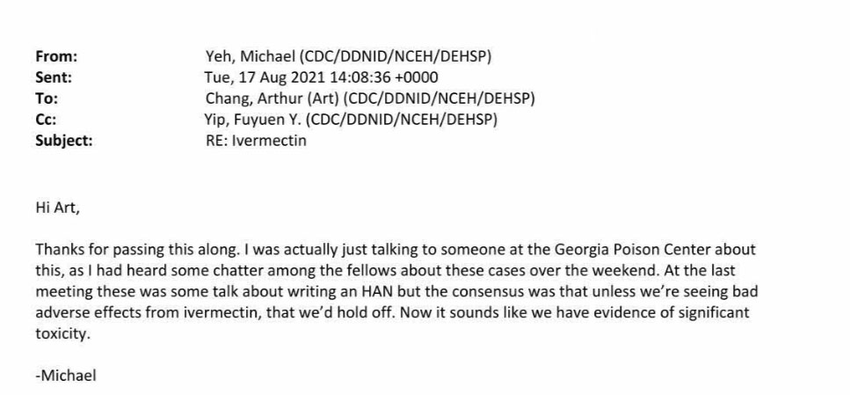
Shortly after learning of [only] three cases, CDC's Michael Yeh writes, “we have evidence of significant toxicity.”

Referring to planning for the health alert, “the consensus was that unless we’re seeing bad adverse effects from ivermectin, we’d hold off,” wrote a CDC medical toxicity officer, Dr. Michael Yeh, in an August 17 email. “Now it sounds like we have evidence of significant toxicity.”
That email was written seventy-two minutes after brief information on three reports arrived in a separate email.
While CDC’s intention might have been to protect people, the alert is emblematic of what had become a national obsession: Portray an early treatment for covid—whether in the animal or human form—as potentially toxic.
CDC hopped aboard.
In an email later that day, Yeh laid out the evidence. The most serious case involved a man, seventy-seven, who had was said to have taken a dose of ivermectin “apparently meant for an 1800 lb. bovine.” He had “hallucinations and tremors, which improved but he was eventually diagnosed with COVID-19” for which he needed only supplemental oxygen, Yeh notes.
In two other cases, a woman who took the human form of the drug was said to have suffered “some confusion.” Another woman had “subjective visual disturbances” after taking “a product meant for sheep” but declined medical help. These side effects are in keeping with what the National Institutes of Health calls a “well-tolerated” anti-parasitic drug with such adverse effects as “dizziness, pruritis, nausea, or diarrhea.”
French researchers published a review last March of 350 ivermectin articles in the medical literature and found adverse effects to be “infrequent and usually mild to moderate.” The study, by the French drugmaker MedinCell, noted that no deaths were reported even after accidental overdoses or suicide attempts.
In view of ivermectin’s well-established safety profile, our request for CDC documents under the Freedom of Information Act sought the rationale for the health alert and specifically asked for the data CDC used from the American Association of Poison Control Centers, to which state centers report. (AAPCC had refused to provide it.)
In response to the FOIA request, CDC asserted, quite remarkably, that it “no longer possesses or has access to the data” because its “licensing agreement” with AAPCC had lapsed. The data might have specified, for example, just how many calls were related either to animal or human formulations; the alert instead lumps all reports together, making it difficult to fathom the extent of livestock ivermectin use.

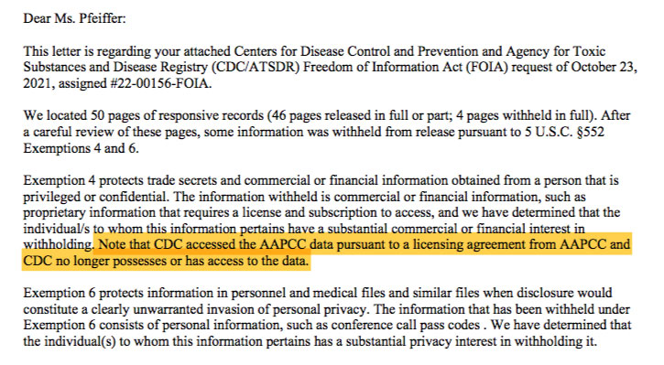
The CDC asserts in a letter to us that it no longer possesses the data on which a national health alert was based.

An increase in ivermectin calls to poison control centers in 2021 is not in dispute, especially as doctors learned of studies showing fewer deaths, shorter hospitalizations, and outpatient success. Poison control centers often see upticks in calls when new drugs come into use, with many callers seeking only information. Centers also field calls on old, long-established medications. Acetaminophen alone generated 47,000 reports in 2019 and led to 164 deaths, according to the AAPCC.
This context, of course, was missing from CDC’s alert. [But] Calls to poison control centers for use of animal and human ivermectin grew [had grown] five- to eight-fold from “pre-pandemic levels,” the alert ominously reported. At the same time, it said, ivermectin prescriptions had soared twenty-four-fold—in a perfectly legal trend led by physicians but one the CDC clearly found unacceptable and alarming.
No distinction was made between animal and human formulations in the alert, which was peppered with phrases like “ivermectin misuse and overdose;” “seizures, coma, and death;” “sheep drench,” “severe illness,” and “rapid increase.” The message: Don’t use either form, even as seventy-one studies show 64 percent of 50,180 patients improved after taking ivermectin for covid.
Despite the alert and New Mexico’s unfounded pronouncements, no one has died from ivermectin poisoning among 2,112 cases logged by AAPCC from January 1 to December 14, 2021. Two percent of those reports, about forty-two, involved a “major” effect, an AAPCC bulletin states. Seventy percent were dismissed as having no effect, “nontoxic exposure,” and the like.
One category of those calls might rightfully have been classified as anti-ivermectin hysteria. New Mexico, for example, urged citizens to report any known ivermectin use to the state’s poison control center, even if “someone you know has taken it.”
We asked Dr. Paul Marik, a founder of the Front Line COVID-19 Critical Care Alliance, his thoughts on the effort to vilify ivermectin as dangerous.
“Ivermectin is one of the safest medications on this planet; far safer than aspirin or acetaminophen,” he said. “This is a fairy tale. Disney could not come up with a better fairy tale.”
But it was no kind of fantasy for the cattleman’s family when he got sick. It was a painful experience with a politicized health system.

A “Very Puzzling” Phone Call
It wasn’t a secret that a cattleman, who died while in New Mexico from covid, took an animal formulation of ivermectin. It is a drug he was well versed in using, having routinely administered it to his herds in Texas.
Others in the family also used Ivomec, a liquid formulation of ivermectin for cattle, since news spread of ivermectin’s effectiveness against covid. “Practically everyone I know takes it,” we were told by a close family friend and business associate of the Texan. (We are withholding the man’s name at the family’s request.)
Ivermectin is just one of 167 drugs tested for safety and approved by the FDA for both animals and humans. Yet those who take either form of ivermectin for covid have been characterized as being anti-science and influenced by “misinformation.”
The Texan is one of two individuals who, according to repeated statements from New Mexico officials, died from “ivermectin toxicity.” While their identities were not revealed by the department of health, a source familiar with the cases released them to us during this investigation.
Documents and interviews with those knowledgeable about the death of the rancher tell a different story than the narrative put forth by New Mexico health officials.
When the cattleman arrived at the ER on the evening of September 2 with his wife, he was soon diagnosed as suffering from acute dehydration as well as being covid positive.
His daughter arrived at the hospital several hours later.
In an interview, she told of the surprise eightieth birthday party for her dad the weekend before, where eight of the eleven family members attending ended up with covid. Everyone seemed to have mild symptoms, she recalled.
With her dad in New Mexico and not feeling well, she suggested he be checked out. “My father was not very good at keeping himself hydrated,” she said, and at that point he didn’t seem to be drinking at all.
He arrived at the hospital dehydrated to the point that his kidneys had become damaged, doctors told the family. Lacking a proper dialysis machine at the Lincoln County Medical Center, the family was told that they were trying to locate another hospital to send him to. Unfortunately, he never made it out of Ruidoso, dying on September 3.
But what happened while his wife and daughter anxiously waited outside the ICU, soon after being informed that the Texan was likely going to pass away, struck them as most peculiar.
His daughter recalled a “very puzzling” phone call her mother received—so disturbing, in fact, that she felt like “yanking the phone from her.”
An unknown man was on the line asking if her father took ivermectin. It was the only time she remembers that particular drug being discussed in the hospital. “I feel like they were pushing her. It was really irritating,” she said, adding, “it was not a doctor or nurse, but mom cannot remember who it was or what they represented.”
They were most interested, she recalled, in grilling her mother about her dad’s use of Ivomec.
At the very next press briefing, Dr. Scrase announced that a “reliable source” reported the state’s “first death” from someone who took ivermectin. While he hedged his bets about the role of ivermectin—and mentioned delayed care—he nonetheless repeatedly characterized the man’s death and one other as specifically being caused by ivermectin.
However, the cattleman’s death certificate, filed at the end of September, says otherwise. It stated he passed away from “natural” causes. His death was not listed as requiring any type of “pending investigation,” and the medical examiner’s office confirmed the fact that no autopsy or toxicology report was done.
But Dr. Scrase’s original tale proved to be very popular with the media. USA Today liked it so much the paper released several versions. “Two die of ivermectin poisoning,” it announced the same day the death certificate was officiated. Five days after that, a headline in The Hill trumpeted, “New Mexico reports two deaths from ivermectin.”
The New Mexico Department of Health has yet to respond to any questions about why a straightforward correction was not made to the media early on regarding the two deaths that were erroneously attributed to ivermectin. It is also not clear why at a recent press briefing the agency was continuing to perpetuate this fallacy even after admitting it was untruthful, rather than correcting the record—and why they have alleged another ivermectin-related death, again without offering any evidence to that effect.

The second supposed ivermectin death involved a thirty-eight-year-old woman from Cuba, New Mexico, reportedly of Navajo heritage. An autopsy was done, but the results have yet to be released.
While Scrase has acknowledged that the two deaths were from covid, not ivermectin, he nonetheless announced what he called yet a “third” ivermectin death at his December 1 briefing.
The new death, Scrase said, is a “60-year-old man who took a horse preparation. This gentleman took 150 milligrams, [suffered] liver failure, kidney failure and actually died from the ivermectin without the covid.”
As with the first two cases, the cause of death remains to be seen.
According to Dr. Marik, 150 milligrams of ivermectin can be safely tolerated. “I do not know of a single case of liver failure and organ failure due to ivermectin,” he wrote in an email.
Both the CDC and New Mexico Department of Health declined to answer questions for this article.

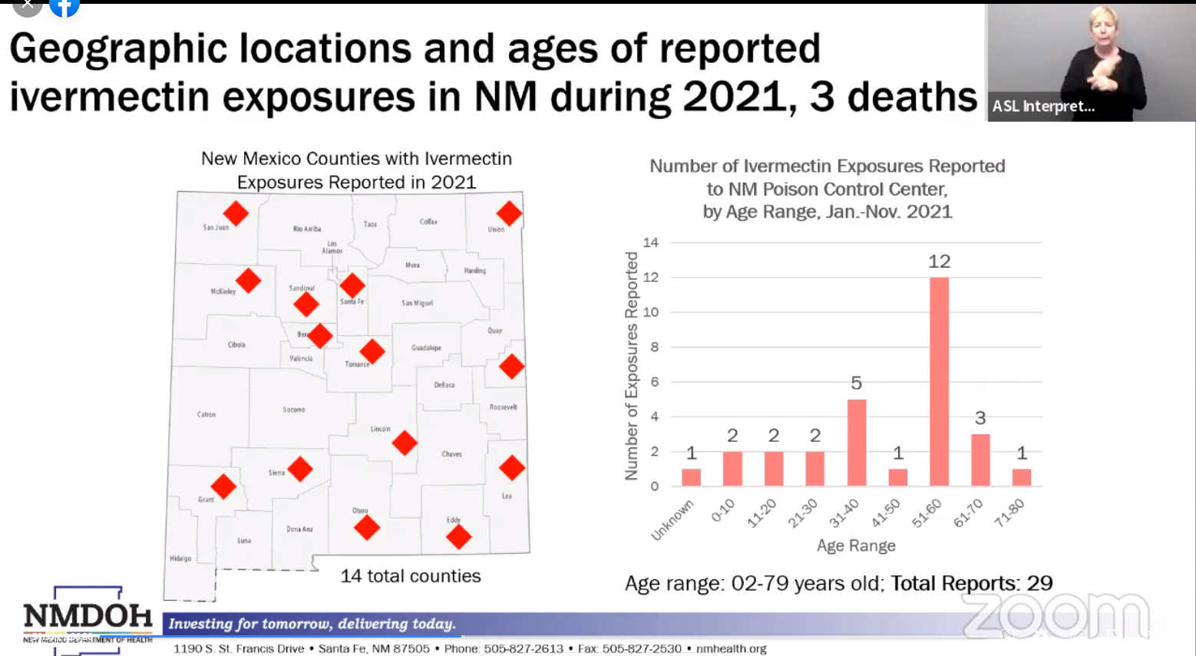
Despite ongoing requests by the New Mexico Department of Health for residents to report any ivermectin use, as this slide displayed during a December 1 press conference shows, only 29 calls came into the state’s poison control center for most all of 2021. The graphic also states that ivermectin caused three deaths in the state, despite the fact that during that very same press briefing it was acknowledged that the first two of the alleged deaths were due to covid, not ivermectin (with no evidence released to support the third claim).

The CDC emails suggest it took very little to convince the agency to issue a national warning about the use of ivermectin. Details on those three cases are scant, the emails show.
Ivermectin dosages are missing or, in one case, described as “concentration unknown.” One woman “was sent to the hospital, but her baseline mental status was unclear.” Another woman was to be contacted for follow-up after declining aid, but there is no indication this was done.
[Authors' Summary Opinion:] These anecdotal bits are the threads from which a mythical tapestry about so-called “ivermectin toxicity” has been woven. This myth lives on in easily accessed online articles.
Among them:
- Mississippi’s health alert on August 19 said 70 percent of poison-control calls were for ingestion of livestock ivermectin. The actual figure was 2 percent; it was not corrected for forty-six days.
- FDA claimed last March to have “received multiple reports” of injury and hospitalization after people took livestock ivermectin. In reality, the agency relied on four reports, a spokesperson said in an email. CDC officials referenced the FDA “consumer warning” when planning their own contribution to the myth of ivermectin harm.
It matters little that false Mississippi figures were corrected (at our behest) by The New York Times, twice, and The Washington Post. What matters is [Authors' Summary Opinion:] the hurricane of fear, whipped up by New Mexico, Mississippi, the FDA, and CDC—and abetted by media—made ivermectin into something it was not.
So where do we stand as vaccines fail and cases rise?
On October 28, WisPolitics.com reported the case of a family that failed to convince a court to give FDA-approved ivermectin to their dying loved one.
“There have been multiple reports nationally,” the website reported, “of people taking the version of the drug intended for animals to combat COVID-19 and sickening themselves in the process.”
Unsupported in the medical literature, the false image of ivermectin convinced doctors in that case to suggest that “the prescribed dosage may be lethal.”
[Authors' Summary Opinion:] Indeed, the invented peril, rather than promise, of ivermectin has become ingrained in the national media and consciousness.
[Authors' Summary Opinion:] That is the story that lives.
Top of Form
 | A guest post by
  Linda Bonvie
  Investigative journalist, freelance health and environmental writer and co-author of several books including "Chemical-Free Kids" and most recently "A Consumer’s Guide to Toxic Food Additives."

 | A guest post by
  Mary Beth Pfeiffer
  I am an investigative journalist who is outraged by the government's abject failure to stop COVID-19 by treating it early. Censorship and greed have fueled this pandemic. My articles: https://www.thefirstepidemic.com/new-index

